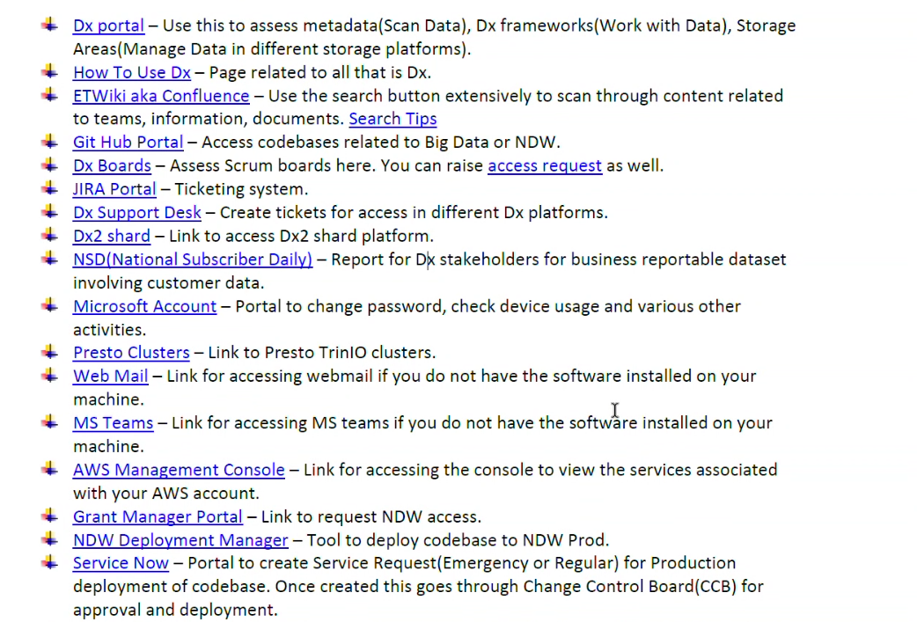

Attached Screenshot का Detailed Explanation (Comcast DX Ecosystem)
आपके screenshot में Comcast/NDW (National Data Warehouse) ecosystem के internal portals और tools दिख रहे हैं। ये सभी tools Data Engineers, Analysts, Developers और Operations teams daily use करती हैं।
🏗️ Overall Purpose of These Portals
ये portals mainly इन कामों के लिए होते हैं:
- Data access
- Metadata management
- Code deployment
- Ticketing
- Production support
- Documentation
- Cloud access
- Cluster access
- Agile/Scrum management

📌 Detailed Explanation of Each Item

1️⃣ Dx Portal
Purpose
Central Data Exchange/Data Experience portal.
Used For
- Metadata scanning
- Dataset discovery
- Storage platform management
- Data catalog access
Data Engineer Uses
- Dataset locate करना
- Table lineage देखना
- Data ownership check करना
Example
अगर आपको customer_usage table चाहिए:
- Dx portal में search करेंगे
- Source system मिलेगा
- Hive/S3 location मिलेगा
- Owner team पता चलेगी

2️⃣ How To Use Dx
Purpose
DX platform training/documentation portal.
Contains
- Step-by-step guides
- Onboarding documents
- Access process
- Usage tutorials
Why Important
New joiners के लिए बहुत important।

3️⃣ ETWiki aka Confluence
Confluence
Purpose
Project documentation portal.
Contains
- Architecture diagrams
- KT documents
- SOPs
- Runbooks
- Deployment steps
- Troubleshooting guides
Very Important For
- KT sessions
- Production support
- Knowledge sharing
Example
Airflow DAG failure fix steps यहाँ documented होते हैं।

4️⃣ GitHub Portal
GitHub
Purpose
Code repository management.
Stores
- Spark jobs
- PySpark scripts
- Airflow DAGs
- Shell scripts
- Deployment configs
Developer Activities
- Pull requests
- Code reviews
- Branch management
- CI/CD integration
Example Structure
repo/
├── dags/
├── spark_jobs/
├── sql/
├── configs/
└── deployment/

5️⃣ Dx Boards
Purpose
Agile/Scrum tracking board.
Used For
- Sprint management
- Task tracking
- Story status
- Backlog management
Status Examples
- To Do
- In Progress
- Testing
- Done

6️⃣ JIRA Portal
Jira
Purpose
Ticketing and work management.
Types of Tickets
- User Story
- Bug
- Enhancement
- Production Issue
- Access Request
Daily Use
- Assign tasks
- Update work logs
- Add comments
- Track sprint progress
Example
NDW-1025
Fix customer ingestion DAG failure

7️⃣ Dx Support Desk
Purpose
Support ticket portal.
Used For
- Access requests
- Cluster issues
- Environment issues
- Permission problems
Example Requests
- Hive access
- S3 bucket access
- Kafka topic permissions

8️⃣ Dx2 Shard
Purpose
Shard/cluster access platform.
What is Shard?
Large data systems को multiple partitions/shards में divide किया जाता है।
Used For
- Distributed processing
- Load balancing
- Large-scale querying

9️⃣ NSD (National Subscriber Daily)
Purpose
Business reporting dataset.
Contains
- Customer subscriber data
- Active customer metrics
- Daily reporting stats
Business Teams Use It For
- Revenue reports
- Subscriber growth
- Customer analytics
Important
Highly governed dataset होता है क्योंकि इसमें customer data रहता है।

🔟 Microsoft Account
Microsoft
Purpose
Corporate account management.
Used For
- Password reset
- MFA
- Device management
- Security settings

1️⃣1️⃣ Presto Clusters
Trino
Purpose
Big Data SQL query engine.
Used For
- Hive querying
- Fast analytics
- Adhoc analysis
Example Query
SELECT * FROM customer_usage WHERE dt='2026-05-14';
Why Important
Huge Hive datasets पर fast SQL execution।

1️⃣2️⃣ Web Mail
Purpose
Corporate email access.
Used For
- Production alerts
- Team communication
- Deployment approvals

1️⃣3️⃣ MS Teams
Microsoft Teams
Purpose
Communication & collaboration.
Used For
- KT sessions
- Daily standups
- Incident calls
- Screen sharing

1️⃣4️⃣ AWS Management Console
Amazon Web Services
Purpose
Cloud resource management.
Data Engineering Services
- S3, EMR, EC2, IAM, Glue, CloudWatch
Common Tasks
- Check S3 files
- Monitor EMR clusters
- View logs

1️⃣5️⃣ Grant Manager Portal
Purpose
Access management portal.
Used For
- NDW access requests
- Role assignment
- Security approvals
Approval Flow : Employee → Manager → Security Team

1️⃣6️⃣ NDW Deployment Manager
Purpose
Production deployment tool.
Used For
- Deploy Spark jobs
- Promote code to production
- Manage releases
Deployment Flow : DEV → QA → UAT → PROD

1️⃣7️⃣ Service Now
ServiceNow
Purpose
ITSM & change management.
Used For
- Production deployment approval
- Incident management
- Change requests
Important Process
CCB (Change Control Board)
Before PROD deployment:
- Change request created
- Approval taken
- Deployment scheduled

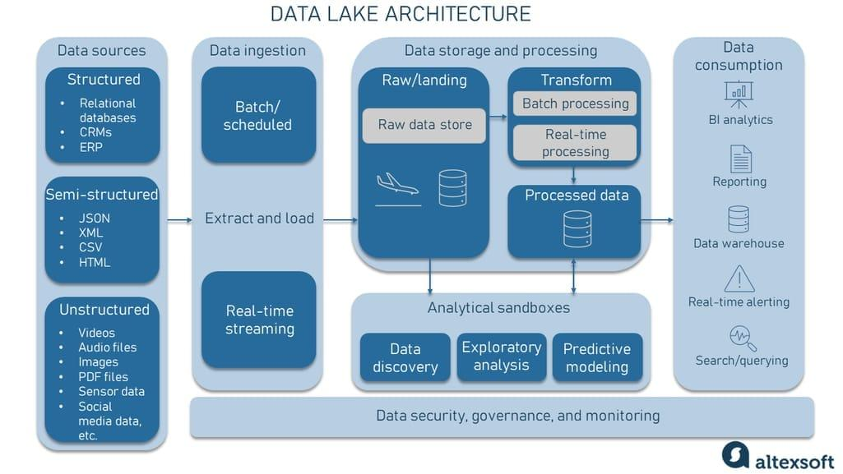
🧠 Overall Comcast Big Data Ecosystem Flow

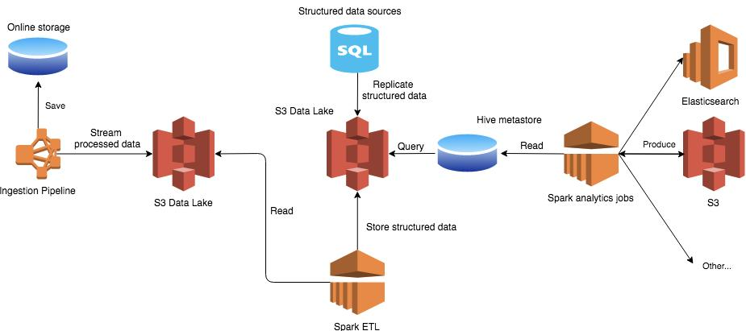

Source Systems
↓
Kafka / APIs / Files
↓
S3 / Hive Raw Layer
↓
Spark / PySpark Processing
↓
Curated Gold Tables
↓
Presto / Tableau / APIs
↓
Business Users

👨‍💻 Real Daily Workflow of Comcast Data Engineer
Morning
- Check Airflow failures, Review Jira tickets, Monitor overnight loads
Development
- Write PySpark code, Test Hive queries, Validate datasets
Deployment
- Create PR in GitHub
- Raise ServiceNow request
- Deploy using NDW Deployment Manager
Production Support
- Fix failed jobs, Restart pipelines, Analyze logs

📌 Important KT Questions Based on This Screenshot
- NDW architecture कैसे organized है?
- DX metadata scan कैसे काम करता है?
- Presto clusters कौन manage करता है?
- Deployment approval process क्या है?
- Production rollback process क्या है?
- Hive table retention policy क्या है?
- Kafka topic ownership कैसे manage होता है?
- S3 bucket naming conventions क्या हैं?
- Airflow monitoring कहाँ होती है?
- Gold datasets कौन consume करता है?

